Pictorial History of the Firm
In April 2006, the son and grandson of the founders of Dickinson, Mackaman, Tyler & Hagen, P.C., recounted the early history of the firm – including many anecdotes and personal memories – to an audience of his colleagues. The presentation was recorded and transcribed, and excerpts of it appear below. This brief memoir, though far from a thorough history of the firm, also tells part of the story of our nation, the city of Des Moines, and the evolution of the practice of law during the 20th century. History buffs are sure to enjoy the following narrative by L. Call Dickinson Jr.

Introduction
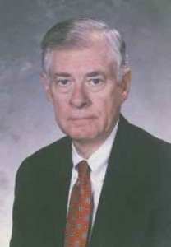

L. CALL DICKINSON JR., 1931-2007
My focus is on the early years of the firm—the founders, the early lawyers, the office accommodations, what is was like to practice law in that era. … There might be some facts in what I talk about, but it is a personal history.
We start with the founding of the firm. The founders were father and son. L.J. Dickinson—everybody called him “Senator,” and after he was a senator, he basically had no other name. He was “Senator” and I’ll call him “Senator.” Then we have L. Call Dickinson, and since I’m a junior and bear the same name, I’ll just call him “Call” and I’ll be “I.”

The Senator
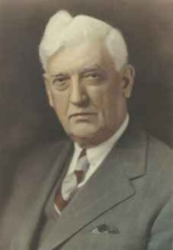

SENATOR LESTER JESSE "L.J." DICKINSON, 1873-1968
The Senator was the son of a farmer—three hundred years of farmers coming from the very, very early part of the founding of this country in the 1600s. The Dickinson ancestors made their way across the country, farming at various stages of the game. The Senator was born in southern Iowa, in the town of Derby, and went to school in Danbury. He expected to be a farmer just like his father; however, his father chose not to expand the farm and there was no opportunity for him to participate adequately on the farm with his father, and so off he goes to college. He went to Cornell College in Mount Vernon. A course of study then was two years. After graduating from Cornell College, he decided to go on and get a law degree and went to the University of Iowa, where it took two years, on top of two years, to become a lawyer.
He met a fellow in his law school named Harrington, and the two of them moved to Algona, Iowa. They set up a practice in Algona in the very early stages of the 1900s, and he was quite successful as a small town lawyer there. He got into a variety of business interests, he was on bank boards—he just was a really popular guy, and everybody kind of thought of him as a guiding light in the community. I guess maybe this acceptance led him to think of himself maybe as a politician, and in due course he did run for Congress—this was back when we had ten Congressman in Iowa, and he was from the tenth congressional district—so he was elected to the U.S. House for the first time in 1918 and served six terms in the U.S. House.
The Senator was always a very, very, very staunch Republican—the best government is no government, keep it out of my life, and if you have to have it, keep it as close to home as you can find it—that was his philosophy. He seemed to be successful in this approach, at least in the state of Iowa. He eventually was elected to the United States Senate in 1930 and achieved some prominence in that era, and eventually was asked to deliver the keynote address to the 1932 Republican convention.
One little anecdote that I always chuckle about when I think of it – there was a very prominent Iowa publisher named Earl Hall who ran the Mason City Globe-Gazette, and he told this story that appeared in the press: He was sitting in the press gallery when the Senator’s speech was being given. Let me digress to say that one of the Senator’s hardest jobs in his political career, one of the most challenging jobs, was to give that speech. Herbert Hoover had the country in the dumps! And for him to get up there and think of all the good things that he could say with a straight face and a lot of enthusiasm about why Herbert Hoover ought to be re-nominated was a challenge! Well, he did his best.
Earl Hall was sitting in the press gallery. He looked down a couple rows, and there was Will Rogers, who was America’s most popular funny man, and he wrote on his convention program, “Mr. Rogers, would you please give me the autograph of the world’s greatest humorist?” He passed it down a couple of rows and it got to Will Rogers and Will Rogers sent it back up to him and he looked at it: “L.J. Dickinson”!
In 1932 things were all right for the Senator, but by 1936 the Roosevelt landslide was in full form, and as you know he was reelected to four terms. The Senator ran again in 1936 and he was defeated. He stayed in Washington for a couple more years, he ran again in 1938. Again, the Roosevelt juggernaut knocked him out—he lost by 2800 votes. By that time he’d had enough and he returned to Algona, Iowa.

Open for Business
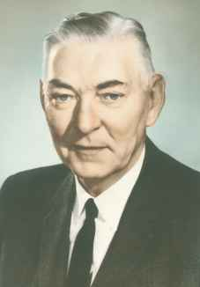

L. CALL DICKINSON SR., 1905-1974
Call Dickinson, in the meantime, graduated from George Washington University, and then George Washington University Law School. He married upon graduation in 1929 and later moved to Des Moines in 1930. He studied for the bar exam and passed the bar. He thereafter served intermittently as a Des Moines office for the Senator, continuing on through the 1938 election. When he wasn’t working for the Senator he was employed by the law firm of Brammer, Brody, Charlton & Parker … . These were very difficult Depression years for a struggling young lawyer who was just a hired hand in another law firm, married, and by that time had about three children.
The early beginnings of the firm occurred when Call strikes off on his own by renting Room 500 in the Fleming Building. The lease commences January 1, 1937.
 | 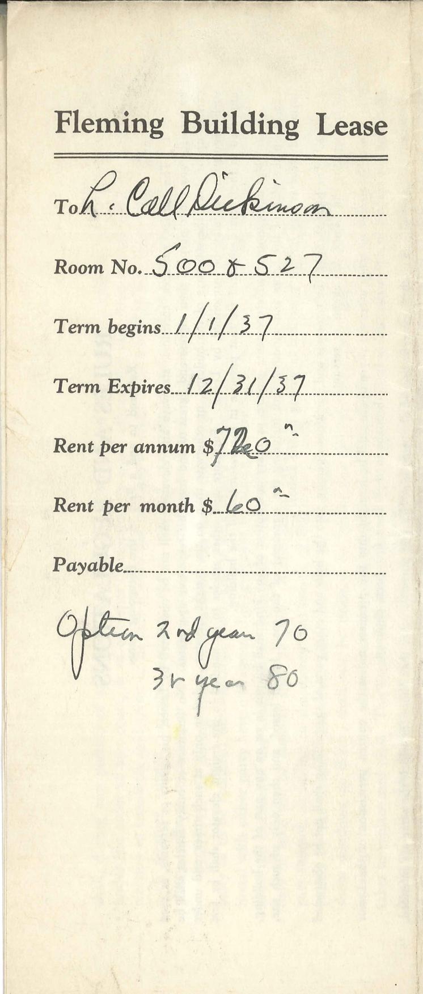
SIXTH AVENUE LOOKING NORTH C. 1909. THE FLEMING BUILDING - ONE OF ONLY TWO BUILDINGS IN IOWA DESIGNED BY FAMED ARCHITECT DANIEL BURNHAM - IS THE TALLEST BUILDING ON THE LEFT. THE POLK COUNTY COURTHOUSE CAN BE SEEN IN THE FOREGROUND ON THE RIGHT, AND ST. AMBROSE CATHEDRAL CAN BE SEEN AT THE HEAD OF THE STREET. IMAGE COURTESY OF LAKE COUNTY DISCOVERY MUSEUM/CURT TEICH POSTCARD ARCHIVES. | THE FIRM'S ORIGINAL LEASE ON THE FIFTH FLOOR OF THE FLEMING BUILDING IN DOWNTOWN DES MOINES, IOWA.

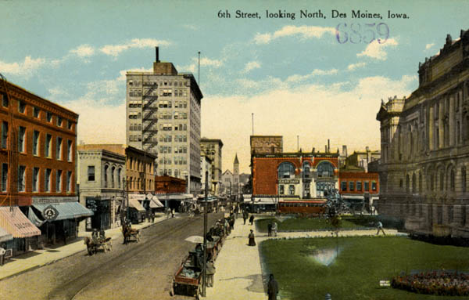
He thought that the best opportunity for a solo practitioner at that point was to become involved in the income tax area. He felt that there was little competition in this area—other lawyers had hardly had taxation in law school, and at this point basically we had no accounting firms in the city. There were a few accountants around, but it would be many years before we would have what you think of as the “Big Eight” or “Six” or “Four” accounting firms here. So, he hired a few lawyers to work for him—this was back in the time when those fellows even babysat my brother and sister and me from time to time. But they were short-timers; they were in and out.
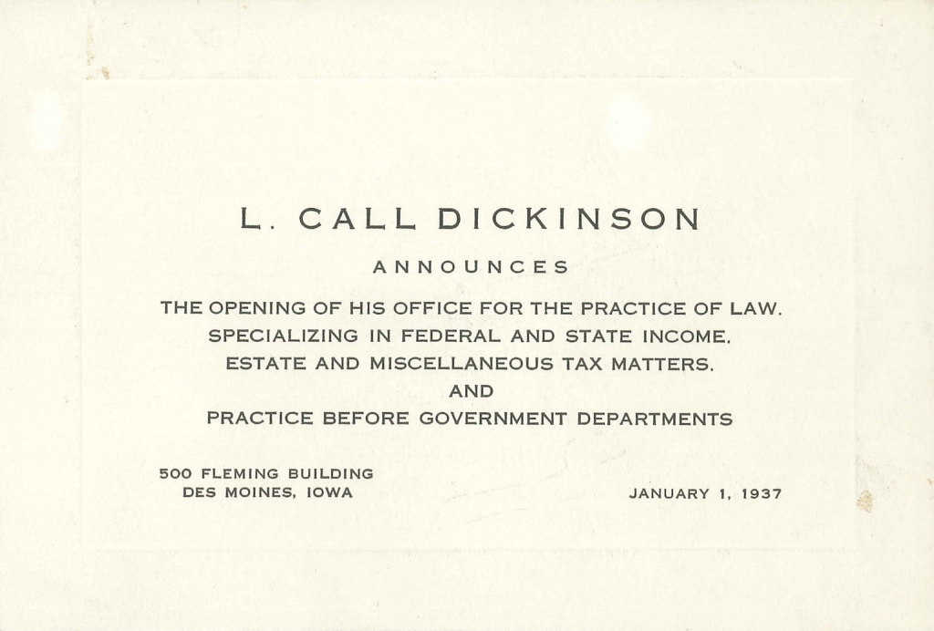

ORIGINAL ANNOUNCEMENT ABOUT THE OFFICIAL OPENING OF THE FIRM FOR BUSINESS ON JANUARY 1, 1937.

Dickinson & Dickinson
The Senator, after having been defeated in 1938 and moving back to Algona for short time, moved to Des Moines and joined my father in the practice of law in 1939 and the firm became known as Dickinson & Dickinson.
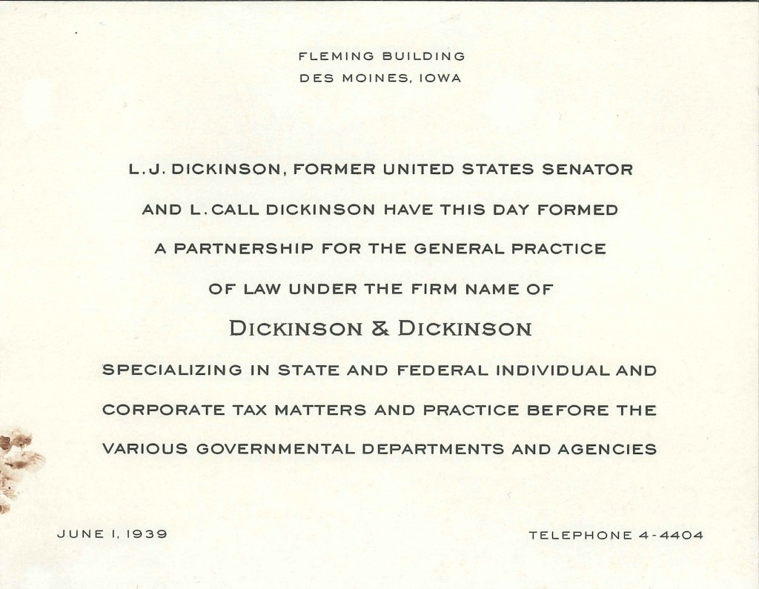

ORIGINAL ANNOUNCEMENT ABOUT SENATOR L.J. DICKINSON JOINING HIS SON'S LAW PRACTICE BEGINNING JUNE 1, 1939.
An addition shortly thereafter was Jens Grothe, who was a former assistant Attorney General. Also joining the firm was Loyal Keir, who was a lawyer that had served with the counsel’s office in the Internal Revenue Service … .
The Senator didn’t bring with him utilities and banks and railroads the way perhaps some people might be thought of doing today. He was truly a public servant. I think the most he made in Congress was $12,000 a year, he walked away with zero pension, he had never had any health insurance or any other kind of benefit, so he had essentially nothing when he left public service and moved to Des Moines. He had no clients, but he was a genuinely wonderful person. He spoke to everybody, he had a great smile, and he had a great laugh. Waiting for the elevator, as he would head home from work, he would pace back and forth with his hands behind his back and whistle some old song. He was a happy fellow, and he would take on almost anybody who came in and needed some help. So he was—given the character of his past experience—the most down-to-earth, humble man one could imagine.

Post-World War II Growth
These were the years during World War II, and they were difficult for everyone. Call was too old and had too many kids to be drafted, so they just made it out with the gas rationing and the food rationing—it was a difficult time for everyone. After the war the vets began to return, and the first to show up was Bob Throckmorton, a Drake Law School graduate. He had gotten a master’s in taxation at Harvard after he left the service and so he decided that he wanted to practice tax law as well and he joined the firm. He came from a family with a prominent medical background—a father and a brother—and he gradually worked his way into developing a practice for the medical society—the Polk County Medical Society—and many other physicians.

Early Emphasis on Tax
When I arrived as a law clerk in early 1957, I was half way though Drake Law School at the time. The client base of the firm did not include banks and utilities and railroads—the kinds of clients that had been useful in supporting the development of many of the other old legacy firms in town; rather, we had mostly individuals and small businesses that predominated in the client base. The origin of the firm was tax practice, and this tended to be for individuals and their small businesses for estate planning, probate, and that type of work.
I spent several years preparing individual income tax returns. John Raife did, as well. When tax season would roll around after the first of the year we would gear up and bring in a very good woman who also helped us, and the three of us made out—I don’t know—several hundred income tax returns every year. This was not unusual. Many, many lawyers all across the state had a large part of their practice devoted to income tax return preparation, and it had reached the point where it became too complicated for individuals, there were no H&R Blocks, there were no accounting firms, and lawyers were the ones that were called on to do that type of work. … Over the years, others came along who could do this work less expensively than the Dickinson firm, and we gradually worked out of the income tax return preparation business and dropped it altogether.

Memories of the Fleming Building
By this time the firm occupied half or a little more of the fifth floor of the Fleming Building. … The office ambiance you might well compare to a third world country. There were a few rooms that had carpets, but others had linoleum. There was no air conditioner. They had glass window deflectors that came in from the windows that shunted the winds up in the air, so the papers wouldn’t blow around off the desks. Paperweights were on every desk. The heating downtown was almost universally by coal, and soot and dust and so on was ever-present, and soot all over the desks and the papers and the dirty sleeves—it was just a way of life. The secretaries would type with up to eight leaves of carbon paper, inserted in onion skin, in order to get a few copies to have everybody be able to share one. And of course when they made a mistake it took forever to erase every one of those pages. No one dreamed of break rooms or coffee or soft drinks—those were just not in the picture.
We had a traumatic shooting in the very next room to the Dickinson law firm at the Royal firm. Apparently there was an unhappy client that came in with a gun blazing and wounded one of the lawyers there. The person was apprehended and eventually prosecuted, and fortunately no one at the firm—our firm—was involved in the fracas, but it surely was exciting.

Early Office Equipment
We were the first firm to get a lot of fancy, new, gee whiz improvements. One of the first I can remember was an Apeco machine. This made the first copy of another paper that I’m aware of that any law firms had. If you got a document from a client and wanted to make a copy of it—well, with this Apeco machine, you put it in and you did mumbo jumbo and out it comes and it’s soaking wet, and there was a clothesline and we had clothespins and you’d hang this document up until it dried and then you had a copy, but that was about the only way you could get a copy of something you didn’t create yourself with a typewriter.
Later—brave new world—along came Thermofax. This was a heat reactive paper and you would put it in the machine and a copy could be reproduced, but it would be reproduced on this thin, scuzzy paper, and for years that’s really all we had. Well, the Fleming Building was heated by radiators, and behind the radiators they were smart enough to build in these boxes so that people could pile files in back of their desks, in lieu of a credenza. Inevitably, you’d get a file out to see what the copy said, and it was all gray because over time the radiator heat would turn the Thermofax paper gray, and whatever was there before was history.
We also had, for the really important documents or when we had to have many copies of something, a Gestetner machine. The secretary would type a stencil and then you’d put it on this machine and put a bunch of paper in there and crank it and every time you’d crank it one copy would come rolling out. So you’d make 25 copies and then you’d have to take the stencil off and go to page two and put that in and crank it through and eventually assemble the documents.
Eventually Call negotiated the purchase of an air conditioner that they put on the fifth floor that cooled the entire fifth floor, and this was really something. The windows were closed and people were really in heaven when this air conditioning came along. …

Continued Growth
In the 1957-58 period, the firm was in need of a trial lawyer. Dale Misseldine was identified. Dale was an in-house lawyer with the Des Moines Transit Company. He brought his claims work for the Des Moines Transit Company to the firm. At the end of the hall, in the Fleming Building, a door was set in and it had on it, “Claims Department, Des Moines Transit Company,” and everybody who lost a purse or got their car dented from a bus or—when the bus stopped too fast, took a spill—or something of this kind, would walk in that door and file a claim. And there was one gal who was very good, Joy was her name—can’t remember her last name—and she handled those folks. Eventually Dale might have to deal with those issues, but he was pretty well occupied with handling defense activities for the Des Moines Transit Company. Eventually he became a district court judge and served with distinction for many years thereafter. …
About 1959, roughly, Ruth Klotz joined the firm. She’s our longtime probate judge. She was hired to do probate work and remained pretty much in that area. She was probably the first woman at any of the larger firms.
The Senator was a mainstay. From 1939, he continued to arrive at the office every day, whether he had work to do or not, and he continued until about age 92. Shortly thereafter he broke a hip and died in 1968 at 94 years of age. …

The 1970s
Call gradually lessened his work at the firm in the following years and he became ill. He did participate in the negotiation of the move to the Financial Center and that lease, but he died in 1974, which is about the year of our move there. He was 69 years old—he died just six years after his father’s death. I was then 43.
After a minor embezzlement by a later bookkeeper, which was an interesting experience, we became the first firm in Iowa to computerize our financial records. We used a firm called CT Law Technology. All of the information about our bookkeeping system would be entered by the bookkeeper into the system and was captured on tape and the tapes were sent to processing in Chicago, and then hard copy was returned here. It was a whole new world. We learned a lot. It was a key benefit to us that everyone got their timesheet in on time—computers don’t wait for anyone—they don’t function until everybody’s accounted for. CT invited me to address a lawyers’ technology group in Atlanta along about this time to kind of relate my experience of going from a non-computerized system to a computerized system. This was a whole big audience of lawyers and small groups. …
We shifted to what we called an administrative committee to manage the firm. Bob Mannheimer handled personnel matters, I handled accounting matters, and John Raife handled office procedures and arrangements—whatever else the others didn’t handle. This committee set the recommended compensation arrangements, hired associates, hired office staff—did whatever had to be done and was no longer being done by Call. I think it was about this time that we hired our first consultant and began to compare notes with what other people were doing around the country. We were doing a lot of things right. At the end I think we were the first firm in Iowa to have a Lexis computer research program. We hired, after the consultant came, the first professional office manager at the firm, Maxine Willits. She stayed maybe ten years, I think grew in the position.
Those are the key highlights, about where I want to end. There’s a story about our move to the Hub Tower in 1986. We eventually formed a professional corporation and changed our method of managing the firm, compensation arrangements, a lot of other things, but I think I’m going to sign off there and let somebody else carry on from that point.

— L. Call Dickinson Jr., Des Moines, Iowa, April 2006

